

**Wellbeing Boost for Schools – Week Seven – Resilience**

**‘Find Ways to Bounce Back’**

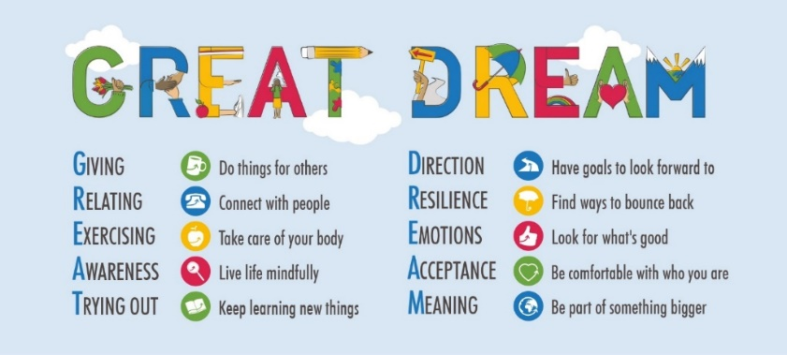 

Dear Colleagues

Welcome to our seventh Wellbeing Boost this term, RESILIENCE. It is worth considering what we mean by resilience, which is commonly thought of as how we can bounce back from difficult situations, but it is also about our capacity to withstand stress. I offer you the image of this very special tree, which grows in South America, experiencing very strong winds whilst the roots and trunk stand firm. I am not sure what the tree is called.

Other interpretations include ‘overcoming adversity’ and ‘being able to adapt to challenging situations.’ However we define resilience it is something that can be learnt and something we can teach children.

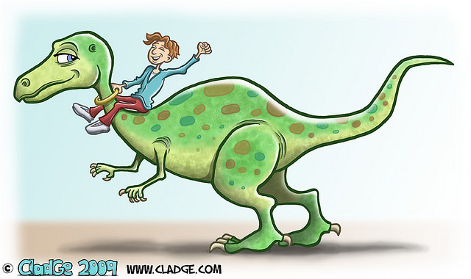

Being resilient doesn’t mean going through life without experiencing stress and pain. People feel grief, sadness, and a range of other emotions after adversity and loss. The road to resilience lies in working through the emotions and stress of painful events. We need to acknowledge and label those feelings.   
  
Resilience is also not something that you’re either born with or not. Resilience develops as people grow up and gain better thinking and self-management skills and more knowledge. Resilience also comes from supportive relationships with parents, peers and others, as well as cultural beliefs and traditions that help people cope with the inevitable bumps in life.  Resilience is found in a variety of behaviours, thoughts, and actions that can be learned and developed across the life span.

How about listening to this great webinar from Dr Chis Johnstone on ‘Practical Resilience,’ learning it for ourselves, many of us who care and teach others.

<https://www.youtube.com/watch?v=sMaiIQy3nbw&feature=emb_logo>

**Factors that contribute to resilience include:**

**(See if you can see elements of GREAT DREAM)**

* Close relationships with family and friends (R)
* A positive view of yourself and confidence in your strengths/abilities (A)
* The ability to manage strong feelings and impulses(E)
* Good problem-solving and communication skills (?)
* Feeling in control (A)
* Seeking help and resources (R)
* Seeing yourself as resilient (rather than as a victim) A
* Coping with stress in healthy ways and avoiding harmful coping strategies, such as substance abuse (E)
* Helping others (G)
* Finding positive meaning in your life despite difficult/traumatic events.M

**Helpful links**

Supporting children to build resilience as children return to school, created by the Educational Psychology Service, Northamptonshire.

<https://www.northamptonshire.gov.uk/councilservices/children-families-education/schools-and-education/educational-psychology-service/Documents/EPS%20Guidance%20-%20Promoting%20Positive%20Transitions%20during%20COVID-19.pdf>

<https://www.bps.org.uk/coronavirus-resources/public/resilience-coping-school>

<https://hbtg.org.uk/wp-content/uploads/2015/06/KAN-Emotional-resilience-toolkit.pdf> (A great resource from West Sussex 2008)

**Ask the children**

* What strengths did they use to overcome a difficult time/situation?
* Give them a research project to find out about someone who has overcome difficulties and discuss how they managed to do that.
* See how many strengths the children can identify in people – make a list.
* When you worry about something, do something that you like doing, then see how you feel. Ask the children to do the same. We can be models.

Share this book, Worries are Like Clouds by Shona Innes with the children and notice how different people deal with worries in different ways. <https://www.goodreads.com/book/show/28929926-worries-are-like-clouds>

Someone that helps me to build my resilience is Simon Aston, who has contributed the section below on developing Digital Resilience – that is all the online stuff that has massively increased during the past year. Simon is the provider of expertise and knowledge in this area across Northamptonshire. So a big thank you to Simon! We do need others to help us – who helps you?

**Digital Resilience** (Information from Simon Aston)

With children and young people spending more time online due to lockdown this has sadly led to an increased risk of exploitation, higher risk of seeing inappropriate content and wellbeing concerns. Now more than ever do we need to really think about building resilience with children online, we need to give them the skills to manage online risks and not block or remove technology from children and young people.



School resources we highly recommend around digital resilience:

* [Digital Resilience Framework](https://assets.publishing.service.gov.uk/government/uploads/system/uploads/attachment_data/file/831217/UKCIS_Digital_Resilience_Framework.pdf) which schools can use as a guide for groups or individuals and we recommend having a look at the self-assessment checklist
* Schools can also use the [Online Resilience Tool](https://www.headstartkernow.org.uk/Digital/Headstart%20online%20resilience%20tool%20WebV2.pdf) by Headstart Kernow which is a practical way to asses young people’s online behaviour
* You can also check out videos on [YouTube](https://www.youtube.com/watch?v=Kr5c5Z1muQM&feature=youtu.be) by Simon Aston the Online Safety and Wellbeing Officer for Northamptonshire County Council, also have a look at our latest parent podcast on [Vimeo](https://vimeo.com/507536439/4127401063) with Oundle School. You can also email us [onlinesafety@northamptonshire.gov.uk](mailto:onlinesafety@northamptonshire.gov.uk) and as always technology is not the problem it’s how we use it.

John Fardon (Education Inclusion Officer – Mental Health)

PS I had meant to share this link from Teeside – so do have a look and I am sure you will find it helpful. <https://teesvalleymuseums.org/diy-museumofkindness/> I know they are planning to release a schools resource pack before Easter.

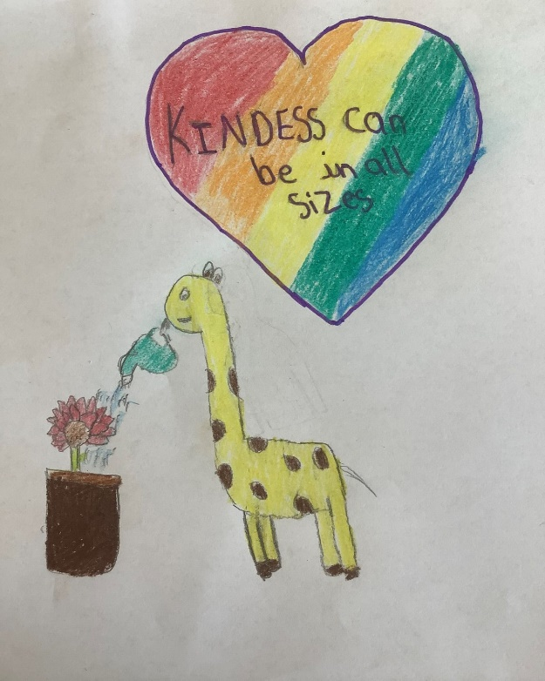

Thank you Hasan for this image in the Museum of Kindness and for the teachers and other children who have supported this project, showing us what is possible and how we can help each other.