

**Wellbeing Boost for Schools – Week Three - Exercising**

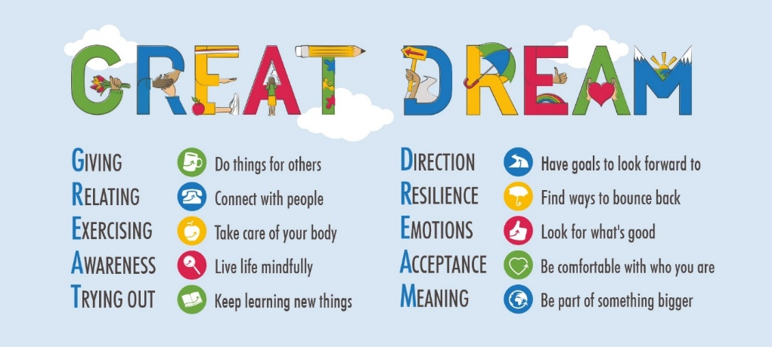

Dear Colleagues

Welcome back to your third Wellbeing Boost this term, which is about exercising and taking care of your body. You are probably well aware that there are connections between the mind and the body. Exercise releases dopamine and endorphins which can lift us out of low mood and depression. I remember many years ago, when I was a teenager, that my Mum used to attend an over 50’s Keep Fit class. She also suffered with depression and I was amazed at how she would come home ‘buzzing’ after her class, quite unlike her coming back from shopping or a meeting!

If you are currently ‘stuck at home’ like me, spending hours on the computer, teaching and communicating online, or you have youngsters at home learning online, we can feel really frustrated, exhausted and maybe quite low.

Here are some simple ideas to consider, some of which you are possibly well aware of:

* Unplug technology and get some fresh air, even for 5 minute mini-breaks.
* Drink more water.
* Eat some more nutritious food.
* Create a circuit of 100 movements with your children, or just for you to do; 25 star jumps, run on the spot for 25 steps, 25 hops on one leg, finally reach down and touch your toes 25 times. Ask the children to invent a circuit for their class, whether they are at home or at school. To benefit from the endorphin release the adults need to join them too!
* Throw a ball against a wall or in the air and catch it x times – what might your record be?
* Dance to music for 5 minutes every hour – great for children to do to relieve stress – ask them to provide the music.
* Create a good bedtime/sleep routine.
* If someone in your school has done Relax Kids training, there are lots of movement exercises to do with children – such as rotating knees, hips, arms and shoulders, swinging arms, opening and closing fingers, shaking your own hands etc Visit [www.relaxkids.com](http://www.relaxkids.com) or see exercises from Place2Be – links at the end of this document.
* If you would like to ‘get fit’ and raise money (GIVING) try <https://charliewaller.org/events/fit-4-feb> and see what else they have on their website regarding mental health.

**Ask the children these questions, talk with them and use their suggestions**

1. What can we do to keep healthy? – walk, move round the house, sleep etc
2. What can we eat to keep healthy? Fruit, veg, eat a little slower, drink water regularly etc
3. What can we remember to do to keep healthy? – wash hands, brush teeth, have a bath/shower etc

* You may already be familiar with Joe Wicks <https://www.google.co.uk/search?sxsrf=ALeKk02NQaVFF_iFx_ml336RfhfnUlSBMw:1611758565240&q=Joe+Wicks+for+kids&sa=X&ved=2ahUKEwiP3PnFrLzuAhXvSxUIHVqMCcMQ1QIwK3oECDQQAQ&biw=1280&bih=609> for a 5 minute kids workout.
* For a more gentle form of exercise try some Yoga <https://www.youtube.com/user/CosmicKidsYoga> or Pilates <https://www.youtube.com/watch?v=CdjRQ6GG8bA>

**FINALLY**

**Place2Be** have their Mental Health Week starting on 1st February, which you can engage with - <https://www.childrensmentalhealthweek.org.uk/> Free ideas and resources for schools and parents, including ideas for movement with children. If you haven’t heard of them visit their website for general information <https://www.place2be.org.uk/> They also have resources and ideas specifically around Coronavirus. <https://www.place2be.org.uk/media/qgje55xe/healthy-inside-and-out-activities-for-schools.pdf>

Best wishes for a happier week ahead and feel free to share this and the other wellbeing boosts when you connect with friends, colleagues and family.

Take care of your mind and body!

John Fardon (Education Inclusion Officer – Mental Health)

